**PRACTICAL NO: 02**

**AIM: Create following Tables:**

**Important Instructions:**

• Use varchar2(30) datatype for Alphanumeric Characters and Special Symbols, number datatype for Numbers, date datatype for Date.

• Use same table and column name (Capital and Small Case) as mentioned in this file.

• Insert proper data (Capital and Small Case) as mentioned in this file.

**TABLE – 1: EMPLOYEE**

|  |  |  |
| --- | --- | --- |
| **Emp_name** | **Street** | **City** |
| Adam | Spring | Pittsfield |
| Brooks | Senator | Brooklyn |
| Curry | North | Rye |
| Demalo | SunShine | San Deago |

**INPUT:**

create table Employee

(emp_name varchar2(20),

street varchar2(20),City varchar2 (20));

insert into Employee (Emp_name,street,city) values ('Adam','Spring','Pittsfield');

insert into Employee (Emp_name,street,city) values ('Brooks','Senator','Brooklyn');

insert into Employee (Emp_name,street,city) values ('Curry','North','Rye');

insert into Employee (Emp_name,street,city) values ('Demalo','SunShine','San Deago');

select * from Employee;

**OUTPUT:**

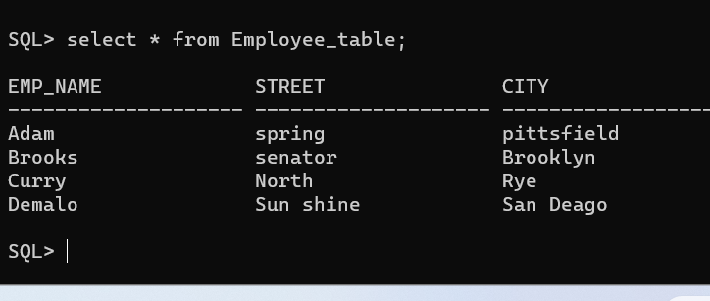

**TABLE – 2: WORK**

|  |  |  |
| --- | --- | --- |
| **Emp_name** | **Cmp_name** | **Salary** |
| Adam | FBC | 20000 |
| Brooks | MBC | 30000 |
| Curry | SBC | 10000 |

**INPUT:**

create table Work

(Emp_name varchar2(20),

Cmp_name varchar2(20),Salary number(20));

insert into Work (emp_name,Cmp_name,Salary) values ('Adam','FBC','20000');

insert into Work (emp_name,Cmp_name,Salary) values ('Brooks','MBC','30000');

insert into Work (emp_name,Cmp_name,Salary) values ('Curry','SBC','10000');

select * from Work

**OUTPUT:**

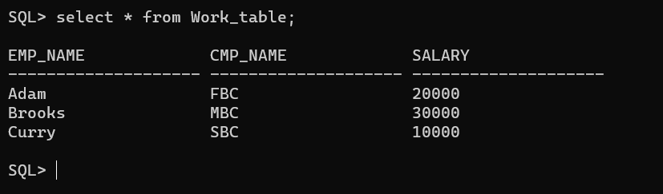

**TABLE-3: COMPANY**

|  |  |
| --- | --- |
| **Cmp_name** | **City** |
| FBC | Pittsfield |
| MBC | Brooklyn |
| SBC | Rye |

**INPUT**

create table Company

(Cmp_name varchar2(20), City varchar2(20));

insert into Company(Cmp_name,City) values('FBC','Pittsfield');

insert into Company(Cmp_name,City) values('MBC','Brooklyn');

insert into Company(Cmp_name,City) values('SBC','Rye');

select * from Company

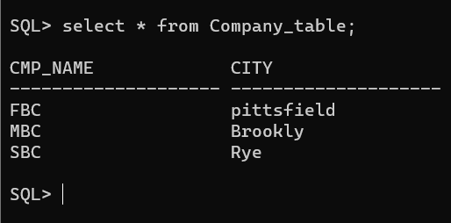**OUTPUT:**

**TABLE-4: MANAGER**

|  |  |
| --- | --- |
| **Emp_name** | **Man_name** |
| Adam | Smith |
| Brooks | Jones |
| Curry | Hayes |

**INPUT:**

create table Manager

(Emp_name varchar2 (20),

Man_name varchar2 (20));

insert into Manager (Emp_name,Man_name) values ('Adam', 'Smith');

insert into Manager (Emp_name,Man_name) values ('Brooks','Jones');

insert into Manager (Emp_name,Man_name) values ('Curry','Hayes');

select * from Manager

**OUTPUT:**

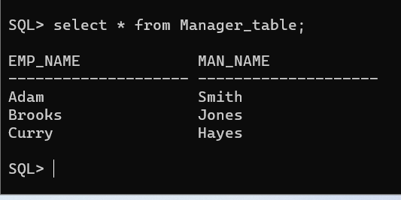

**TABLE-5: SAILORS**

|  |  |  |  |
| --- | --- | --- | --- |
| **Sid** | **Sname** | **Rating** | **Age** |
| 22 | Dustin | 7 | 45.0 |
| 29 | Brutus | 1 | 33.0 |
| 31 | Lubber | 8 | 55.5 |
| 32 | Andy | 8 | 25.5 |
| 58 | Rusty | 10 | 35.0 |
| 64 | Horatio | 7 | 35.0 |
| 71 | Zobra | 10 | 16.0 |
| 74 | Horatio | 9 | 35.0 |
| 85 | Art | 3 | 25.5 |
| 95 | Bob | 3 | 63.5 |

**INPUT**

create table Sailors

(Sid number(20),

Sname varchar(20),Rating number(20),

Age number(10,2));

insert into Sailors (Sid,Sname,Rating,Age) values ('22','dustin','7','45.0')

insert into Sailors (Sid,Sname,Rating,Age) values ('29','brutus','1','33.0')

insert into Sailors (Sid,Sname,Rating,Age) values ('31','lubber','8','55.5')

insert into Sailors (Sid,Sname,Rating,Age) values ('32','Andy','8','25.5')

insert into Sailors (Sid,Sname,Rating,Age) values ('58','Rusty','10','35.0')

insert into Sailors (Sid,Sname,Rating,Age) values ('64','Horatio','7','35.0')

insert into Sailors (Sid,Sname,Rating,Age) values ('71','Zobra','10','16.0')

insert into Sailors (Sid,Sname,Rating,Age) values ('74','Horatio','9','35.0')

insert into Sailors (Sid,Sname,Rating,Age) values ('85','Art','3','25.5')

insert into Sailors (Sid,Sname,Rating,Age) values ('95','Bob','3','63.5')

select * from Sailors

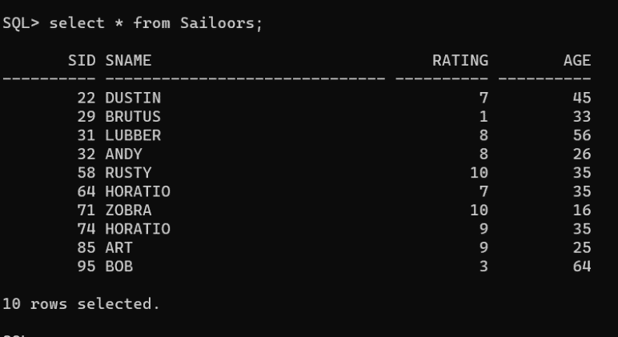**OUTPUT:**

**TABLE -6: RESERVES**

|  |  |  |
| --- | --- | --- |
| **Sid** | **Bid** | **Day** |
| 22 | 101 | 10 -oct- 98 |
| 22 | 102 | 10 -oct- 98 |
| 22 | 103 | 10 -aug 98 |
| 22 | 104 | 10 -jul- 98 |
| 31 | 102 | 11 –oct- 98 |
| 31 | 103 | 11 –jun- 98 |
| 31 | 104 | 11 –dec- 98 |
| 64 | 101 | 9 –may- 98 |
| 64 | 102 | 9 – aug- 98 |
| 74 | 103 | 9 –aug- 98 |

**INPUT:**

create table Reserves

(sid NUMBER,bid NUMBER,day DATE);

insert into Reserves (sid,bid,day) values('22','101', to_date('10-10-1998','MM-DD-YYYY'));

insert into Reserves (sid,bid,day) values('22','102', to_date('10-10-1998','MM-DD-YYYY'));

insert into Reserves (sid,bid,day) values('22','103', to_date('08-10-1998','MM-DD-YYYY'));

insert into Reserves (sid,bid,day) values('22','104', to_date('07-10-1998','MM-DD-YYYY'));

insert into Reserves (sid,bid,day) values('31','102', to_date('10-11-1998','MM-DD-YYYY'));

insert into Reserves (sid,bid,day) values('31’,'103', to_date('06-11-1998','MM-DD-YYYY'));

insert into Reserves (sid,bid,day) values('31','104', to_date('12-11-1998','MM-DD-YYYY'));

insert into Reserves (sid,bid,day) values(‘64','101', to_date('05-09-1998','MM-DD-YYYY'));

insert into Reserves (sid,bid,day) values('64','102', to_date('08-09-1998','MM-DD-YYYY'));

insert into Reserves (sid,bid,day) values('74','103', to_date('08-09-1998','MM-DD-YYYY'));

select * from Reserves

**OUTPUT:**

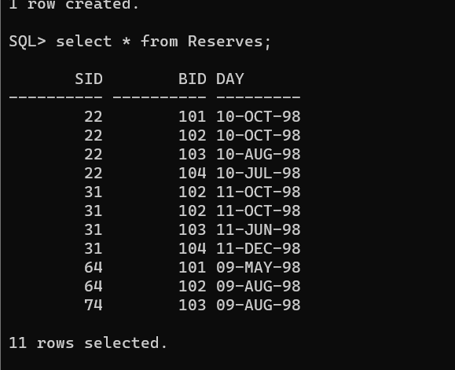

**TABLE – 7: BOATS**

|  |  |  |
| --- | --- | --- |
| **Bid** | **Bname** | **Color** |
| 101 | Interlake | Blue |
| 102 | Interlake | Red |
| 103 | Clipper | Green |
| 104 | Marine | Red |

**INPUT:**

create table Boats

(Bid number(20),Bname varchar(20),Color varchar(20));

insert into Boats (Bid,Bname,Color) values ('101','Interlake','Blue');

insert into Boats (Bid,Bname,Color) values ('102','Interlake','Red');

insert into Boats (Bid,Bname,Color) values ('103','Clipper','Green');

insert into Boats (Bid,Bname,Color) values ('104','Marine','Red');

select * from Boats

**OUTPUT:**

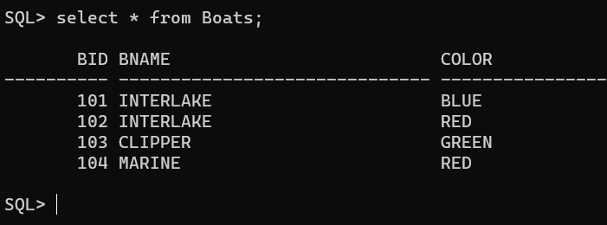

**TABLE – 8: CLIENT**

|  |  |  |  |  |  |
| --- | --- | --- | --- | --- | --- |
| **Cl_no** | **Name** | **City** | **Pincode** | **State** | **Baldue** |
| C00001 | Ivan Bayross | Mumbai | 400054 | Maharashtra | 15000 |
| C00002 | Mamta Muzumdar | Madras | 780001 | Tamil Nadu | 100 |
| C00003 | Chhaya Bankar | Mumbai | 400057 | Maharashtra | 5000 |
| C00004 | Ashwini Joshi | Bangalore | 560001 | Karnataka | 500 |
| C00005 | Hansel Colaco | Mumbai | 400060 | Maharashtra | 2000 |
| C00006 | Deepak Sharma | Mangalore | 560050 | Karnataka | 1000 |

**INPUT:**

create table Client

(Cl_no varchar(20), Name Varchar(20),City varchar (20),Pincode number(20),State varchar(20),Baldue number(20));

insert into Client (Cl_no,Name,City,Pincode,State,Baldue) values ('C00001','Ivan Bayross','Mumbai','400054','Maharashtra','15000');

insert into Client (Cl_no,Name,City,Pincode,State,Baldue) values ('C00002','Manmta Muzumbar','Madras','780001','Tamil Nadu','100');

insert into Client (Cl_no,Name,City,Pincode,State,Baldue) values ('C00003','Chhaya Bankar','Mumbai','400057','Maharashtra','5000');

insert into Client (Cl_no,Name,City,Pincode,State,Baldue) values ('C00004','Ashwini Joshi','Bangalore','560001','Karnataka','500');

insert into Client (Cl_no,Name,City,Pincode,State,Baldue) values ('C00005','Hansel Colaco','Mumbai','400060','Maharashtra','2000');

insert into Client (Cl_no,Name,City,Pincode,State,Baldue) values ('C00006','Deepak Sharma','Mangalore','560050','Karnataka','1000');

select * from Client

**OUTPUT:**

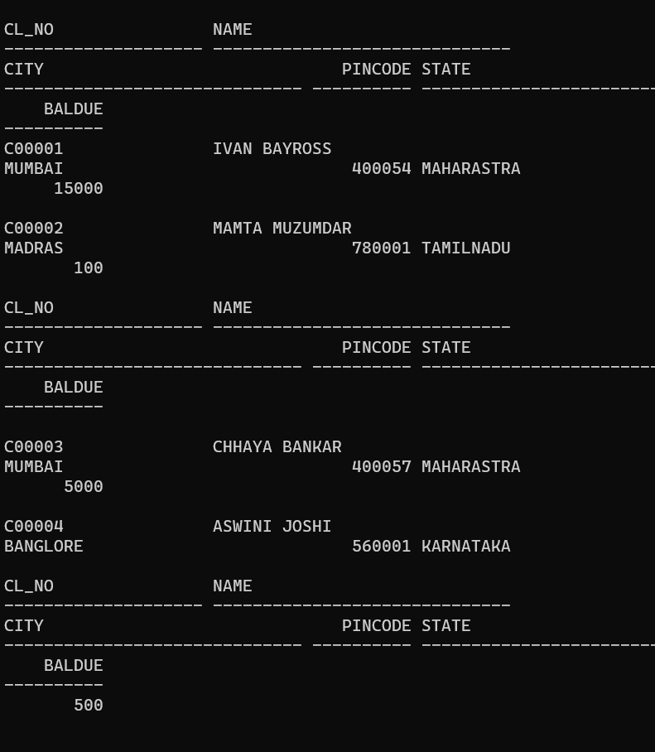

**TABLE-9: PRODUCT**

|  |  |  |  |  |  |  |  |
| --- | --- | --- | --- | --- | --- | --- | --- |
| **Pr_no** | **Dscr** | **Profit** | **Unit** | **Qty** | **Reorder_Lvl** | **Sell_Price** | **Cost_Price** |
| P00001 | T-Shirts | 5 | Piece | 200 | 50 | 350 | 250 |
| P0345 | Shirts | 6 | Piece | 150 | 50 | 500 | 350 |
| P06734 | Cotton Jeans | 5 | Piece | 100 | 20 | 600 | 450 |
| P07865 | Jeans | 5 | Piece | 100 | 20 | 750 | 500 |
| P07868 | Trousers | 2 | Piece | 150 | 50 | 850 | 550 |
| P07885 | Pull Overs | 3 | Piece | 80 | 30 | 700 | 450 |
| P07965 | Denim Shirts | 4 | Piece | 100 | 40 | 350 | 250 |
| P07975 | Lycra Tops | 5 | Piece | 70 | 30 | 300 | 175 |
| P08865 | Skirts | 5 | Piece | 75 | 30 | 450 | 300 |

**INPUT:**

create table Product

(Pr_no varchar(20), Dscr varchar2(20),Profit number(20),

Unit varchar2(20), Qty number(20), Reorder_Lvl number(20), Sell_Price number(20), Cost_price number(20));

insert into Product (Pr_no,Dscr,Profit,Unit,Qty,Reorder_Lvl,Sell_Price,Cost_Price) values ('P00001','T-Shirts','5','Piece','200','50','350','250');

insert into Product (Pr_no,Dscr,Profit,Unit,Qty,Reorder_Lvl,Sell_Price,Cost_Price) values ('P0345','Shirts','6','Piece','150','50','500','350');

insert into Product (Pr_no,Dscr,Profit,Unit,Qty,Reorder_Lvl,Sell_Price,Cost_Price) values ('P06734','Cotton Jeans','5','Piece','100','20','600','450');

insert into Product (Pr_no,Dscr,Profit,Unit,Qty,Reorder_Lvl,Sell_Price,Cost_Price) values ('P07865','Jeans','5','Piece','100','20','750','500');

insert into Product (Pr_no,Dscr,Profit,Unit,Qty,Reorder_Lvl,Sell_Price,Cost_Price) values ('P07868','Trousers','2','Piece','150','50','850','550');

insert into Product (Pr_no,Dscr,Profit,Unit,Qty,Reorder_Lvl,Sell_Price,Cost_Price) values ('P07885','Pull Overs','3','Piece','80','30','700','450');

insert into Product (Pr_no,Dscr,Profit,Unit,Qty,Reorder_Lvl,Sell_Price,Cost_Price) values ('P07965','Denim Shirts','4','Piece','100','40','350','250');

insert into Product (Pr_no,Dscr,Profit,Unit,Qty,Reorder_Lvl,Sell_Price,Cost_Price) values ('P07975','Lycra Tops','5','Piece','70','30','300','175');

insert into Product (Pr_no,Dscr,Profit,Unit,Qty,Reorder_Lvl,Sell_Price,Cost_Price) values ('P08865','Skirts','5','Piece','75','30','450','300');

select * from Product

**OUTPUT:**

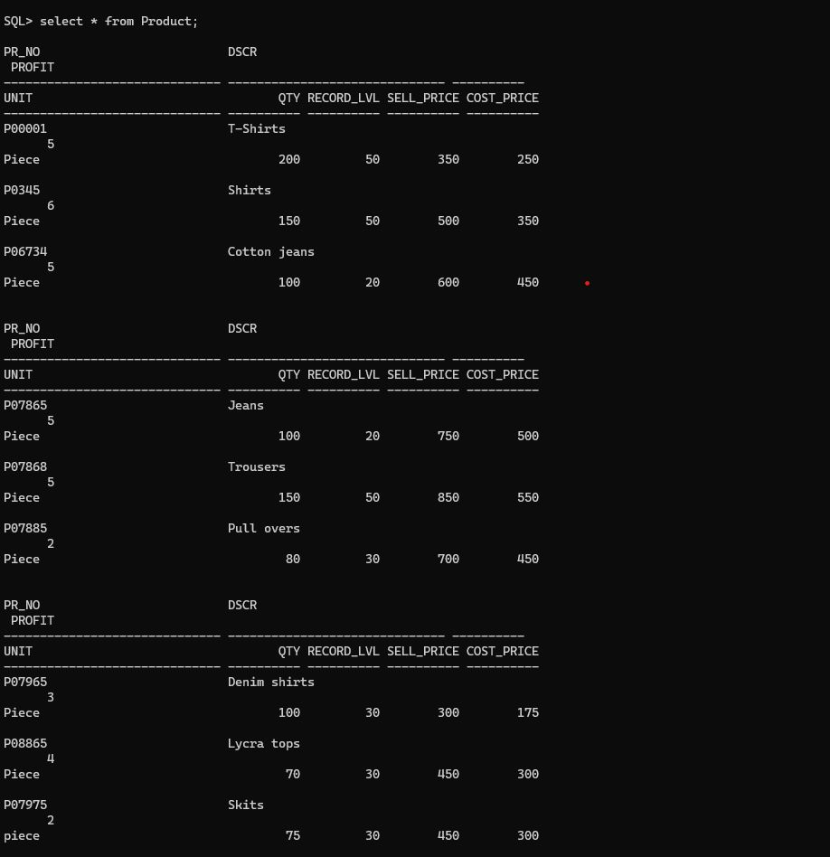

**TABLE-10: SALESMAN**

|  |  |  |  |  |  |  |  |  |  |  |
| --- | --- | --- | --- | --- | --- | --- | --- | --- | --- | --- |
| **Sl_no** | **Name** | **Add1** | **Add2** | **City** | **Pin** | **State** | **Amt** | **Tgt** | **Sales** | **Rem** |
| S00001 | Aman | A/14 | Worli | Mumbai | 400002 | Maharashtra | 3000 | 100 | 50 | Good |
| S00002 | Omkar | 65 | Nariman | Mumbai | 400001 | Maharashtra | 3000 | 200 | 100 | Good |
| S00003 | Raj | P-7 | Bandra | Mumbai | 400032 | Maharashtra | 3000 | 200 | 100 | Good |
| S00004 | Ashish | A/5 | Juhu | Mumbai | 400044 | Maharashtra | 3500 | 200 | 150 | Good |

**INPUT:**

create table Salesman

(Sl_no varchar2(20),Name varchar2(20),Add1 varchar2(20),Add2 varchar2(20),City varchar2(20),Pin number(20), State varchar2(20), Amt number(20),Tgt number(20),Sales number(20), Rem varchar2(20));

insert into Salesman (Sl_no,Name,Add1,Add2,City,Pin,State,Amt,Tgt,Sales,Rem)

values ('S00001','Aman','A/14','Worli','Mumbai','400002','Maharasthra','3000','100','50','Good');

insert into Salesman (Sl_no,Name,Add1,Add2,City,Pin,State,Amt,Tgt,Sales,Rem)

values ('S00001','Omkar','65','Nariman','Mumbai','400001','Maharasthra','3000','200','100','Good');

insert into Salesman (Sl_no,Name,Add1,Add2,City,Pin,State,Amt,Tgt,Sales,Rem)

values ('S00003','Raj','P-7','Bandra','Mumbai','400032','Maharasthra','3000','200','100','Good');

insert into Salesman (Sl_no,Name,Add1,Add2,City,Pin,State,Amt,Tgt,Sales,Rem)

values ('S00004','Ashish','A/5','Juhu','Mumbai','400044','Maharasthra','3500','200','150','Good');

select * from Salesman

**OUTPUT:**

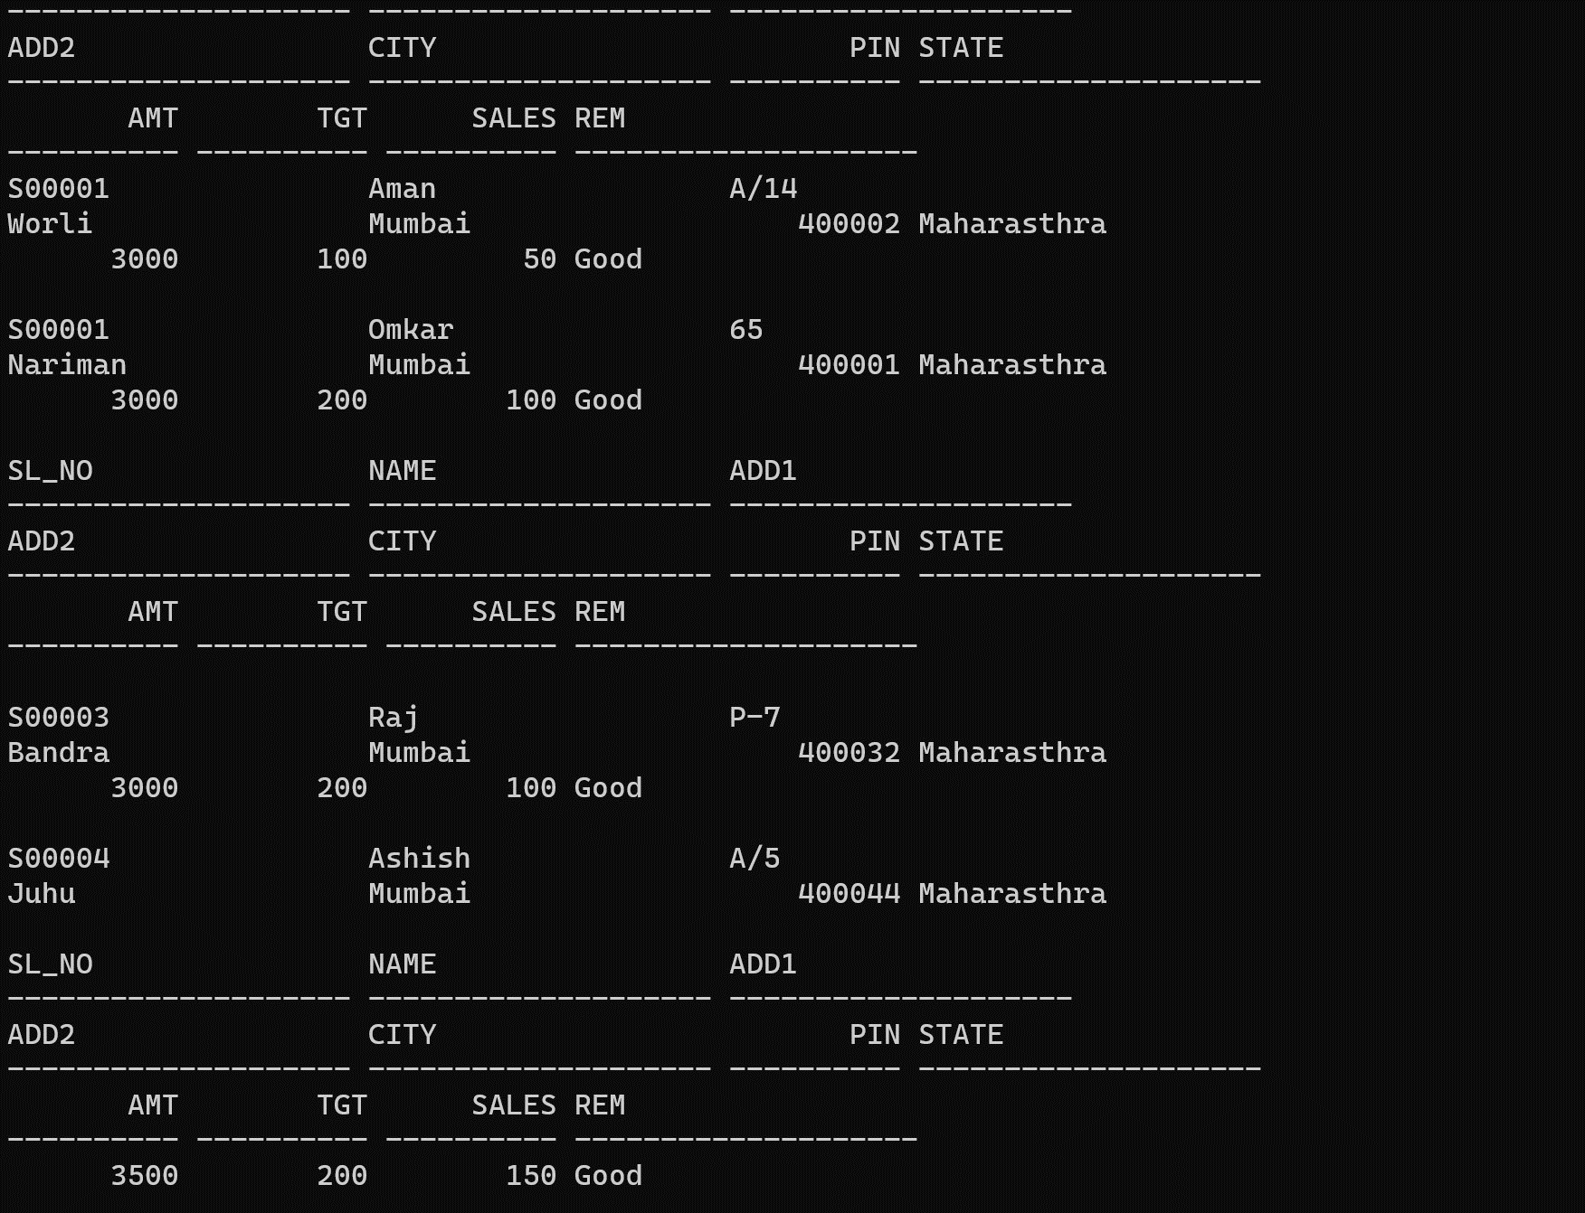

**TABLE-11: SALESORDER**

|  |  |  |  |  |  |  |  |
| --- | --- | --- | --- | --- | --- | --- | --- |
| **Od_no** | **Cl_no** | **O_dat** | **Sl_no** | **D-Type** | **Bill** | **D_dat** | **Status** |
| O19001 | C00001 | 12-JUN-04 | S00001 | F | N | 20-JUL-04 | In Process |
| O19002 | C00002 | 25-JUN-04 | S00002 | P | N | 27-JUN04 | Cancelled |
| O46865 | C00003 | 18-FEB-04 | S00003 | F | Y | 20-FEB-04 | Fulfilled |
| O19003 | C00001 | 03-APR-04 | S00001 | F | Y | 07-APR-04 | Fulfilled |
| O46866 | C00004 | 20-MAY-04 | S00002 | P | N | 22-MAY-04 | Cancelled |
| O19008 | C00005 | 24-MAY-04 | S00004 | F | N | 26-JUL-04 | In Process |

**INPUT:**

create table Salesorder

(Od_no varchar2(20), Cl_no varchar2(20), O_dat DATE, Sl_no varchar2(20), D_Type char(1),

Bill char(1),D_dat DATE,Status varchar2(20));

insert into Salesorder (Od_no, Cl_no, O_dat, Sl_no, D_Type, Bill, D_dat, Status)

values ('O19002', 'C00002', DATE '2004-06-25', 'S00002', 'P', 'N', DATE '2004-06-27', 'Cancelled');

insert into Salesorder (Od_no, Cl_no, O_dat, Sl_no, D_Type, Bill, D_dat, Status)

values ('O46865', 'C00003', DATE '2004-02-18', 'S00003', 'F', 'Y', DATE '2004-02-20', 'Fulfilled');

insert into Salesorder (Od_no, Cl_no, O_dat, Sl_no, D_Type, Bill, D_dat, Status)

values ('O19003', 'C00001', DATE '2004-04-03', 'S00001', 'F', 'Y', DATE '2004-04-07', 'Fulfilled');

insert into Salesorder (Od_no, Cl_no, O_dat, Sl_no, D_Type, Bill, D_dat, Status)

values ('O46866', 'C00004', DATE '2004-05-20', 'S00002', 'P', 'N', DATE '2004-05-22', 'Cancelled');

insert into Salesorder (Od_no, Cl_no, O_dat, Sl_no, D_Type, Bill, D_dat, Status)

values ('O19008', 'C00005', DATE '2004-05-24', 'S00004', 'F', 'N', DATE '2004-07-26', 'In Process');

select * from Salesorder

**OUTPUT:** 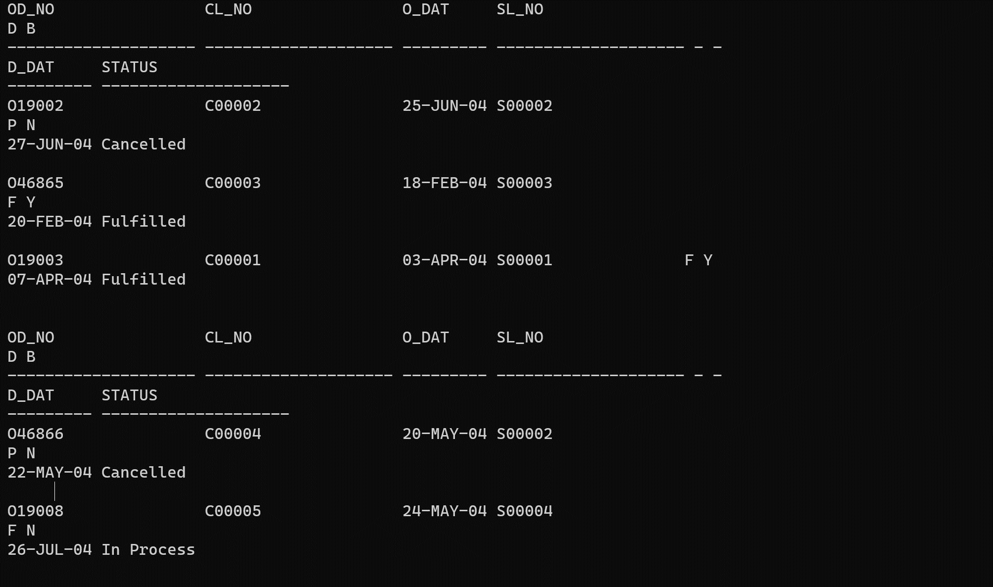

**TABLE-12: SALESORDER_DETAILS**

|  |  |  |  |  |
| --- | --- | --- | --- | --- |
| **Od_no** | **Pr_no** | **Qty_order** | **Qty_disp** | **Rate** |
| O19001 | P00001 | 4 | 4 | 525 |
| O19001 | P07965 | 2 | 1 | 8400 |
| O19001 | P07885 | 2 | 1 | 5250 |
| O19002 | P00001 | 10 | 0 | 525 |
| O46865 | P07868 | 3 | 3 | 3150 |
| O46865 | P07885 | 3 | 1 | 5250 |
| O46865 | P00001 | 10 | 10 | 525 |
| O46865 | P0345 | 4 | 4 | 1050 |
| O19003 | P0345 | 2 | 2 | 1050 |
| O19003 | P06734 | 1 | 1 | 12000 |
| O46866 | P07965 | 1 | 0 | 8400 |
| O46866 | P07975 | 1 | 0 | 1050 |
| O19008 | P00001 | 10 | 5 | 525 |
| O19008 | P07975 | 5 | 3 | 1050 |

**INPUT:**

create table Salesorder_Details

(Od_no varchar2(20),Pr_no varchar2(20), Qty_order number(20), Qty_disp number(20),Rate number(20));

insert into Salesorder_Details (Od_no,Pr_no,Qty_order,Qty_disp,Rate) values ('O19001','P00001','4','4','525');

insert into Salesorder_Details (Od_no,Pr_no,Qty_order,Qty_disp,Rate) values ('O19001','P07965','2','1','8400');

insert into Salesorder_Details (Od_no,Pr_no,Qty_order,Qty_disp,Rate) values ('O19001','P07885','2','1','5250');

insert into Salesorder_Details (Od_no,Pr_no,Qty_order,Qty_disp,Rate) values ('O19002','P00001','10','0','525');

insert into Salesorder_Details (Od_no,Pr_no,Qty_order,Qty_disp,Rate) values ('O46865','P07868','3','3','3150');

insert into Salesorder_Details (Od_no,Pr_no,Qty_order,Qty_disp,Rate) values ('O46865','P07865','3','1','5250');

insert into Salesorder_Details (Od_no,Pr_no,Qty_order,Qty_disp,Rate) values ('O46865','P00001','10','10','525');

insert into Salesorder_Details (Od_no,Pr_no,Qty_order,Qty_disp,Rate) values ('O46865','P0345','4','4','1050');

insert into Salesorder_Details (Od_no,Pr_no,Qty_order,Qty_disp,Rate) values ('O19003','P0345','2','2','1050');

insert into Salesorder_Details (Od_no,Pr_no,Qty_order,Qty_disp,Rate) values ('O19003','P06734','1','1','12000');

insert into Salesorder_Details (Od_no,Pr_no,Qty_order,Qty_disp,Rate) values ('O46866','P07965','1','0','8400');

insert into Salesorder_Details (Od_no,Pr_no,Qty_order,Qty_disp,Rate) values ('O46866','P07975','1','0','1050');

insert into Salesorder_Details (Od_no,Pr_no,Qty_order,Qty_disp,Rate) values ('O191008','P00001','10','5','525');

insert into Salesorder_Details (Od_no,Pr_no,Qty_order,Qty_disp,Rate) values ('O191008','P07975','5','3','1050');

select * from Salesorder_Details

**OUTPUT:**

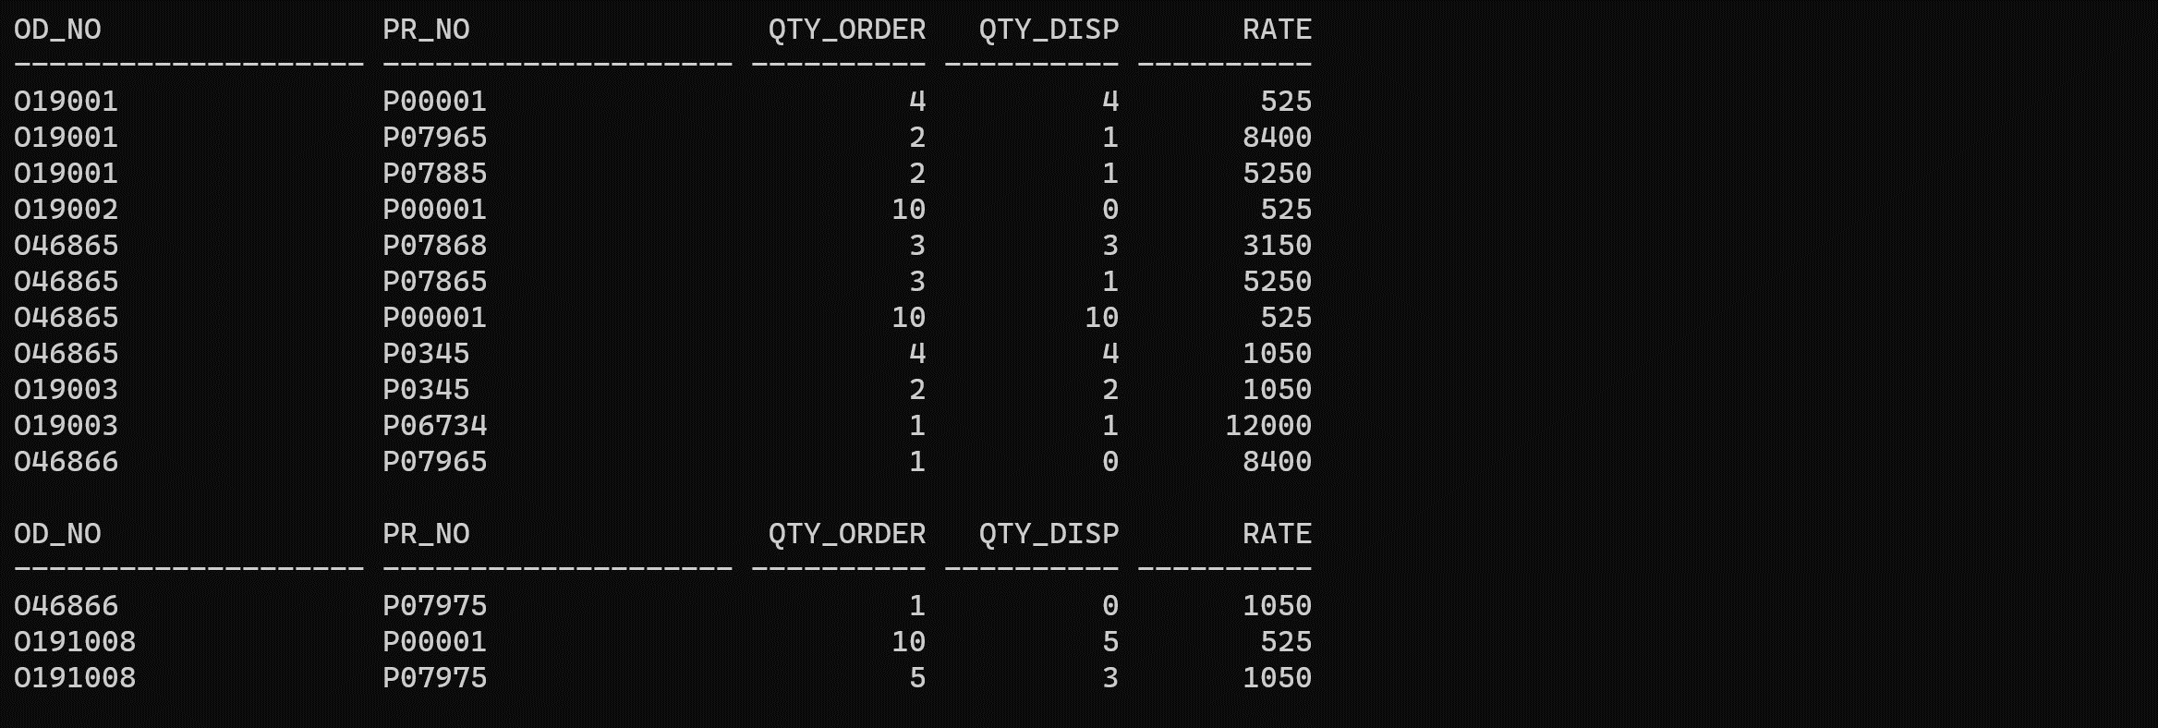

**TABLE-13: DEPOSIT**

|  |  |  |  |  |
| --- | --- | --- | --- | --- |
| **Act_ no** | **Cname** | **Bname** | **Amount** | **Date** |
| 100 | ANIL | VRCE | 1000.00 | 1-MAR-95 |
| 101 | SUNIL | AJNI | 5000.00 | 4-JAN-96 |
| 102 | MEHUL | KAROLBAGH | 3500.00 | 17-NOV-95 |
| 104 | MADHURI | CHANDI | 1200.00 | 17-DEC-95 |
| 105 | PRMOD | M.G.ROAD | 3000.00 | 27-MAR-96 |
| 106 | SANDIP | ANDHERI | 2000.00 | 31-MAR-96 |
| 107 | SHIVANI | VIRAR | 1000.00 | 5-SEP-95 |
| 108 | KRANTI | NEHRU PLACE | 5000.00 | 2-JUL-95 |
| 109 | MINU | POWAI | 7000.00 | 10-AUG-95 |

**INPUT:**

create table Deposit

(Act_no VARCHAR2(10), Cname VARCHAR2(50), Bname VARCHAR2(50),Amount NUMBER(10, 2),"Date" DATE);

insert into Deposit (Act_no, Cname, Bname, Amount, "Date")

values ('100','ANIL','VRCE', 1000.00, DATE '95-03-01');

insert into Deposit (Act_no, Cname, Bname, Amount, "Date")

values ('101','SUNIL','AJNI', 5000.00, DATE '96-01-04');

insert into Deposit (Act_no, Cname, Bname, Amount, "Date")

values ('102','MEHUL','KAROL BAGH', 3500.00, DATE '95-11-17');

insert into Deposit (Act_no, Cname, Bname, Amount, "Date")

values ('104','MADHURI','CHANDI', 1200.00, DATE '95-12-17');

insert into Deposit (Act_no, Cname, Bname, Amount, "Date")

values ('105','PRMOD','M.G.ROAD', 3000.00, DATE '96-03-27');

insert into Deposit (Act_no, Cname, Bname, Amount, "Date")

values ('106','SANDIP','ANDHERI', 2000.00, DATE '96-03-31');

insert into Deposit (Act_no, Cname, Bname, Amount, "Date")

values ('107','SHIVANI','VIRAR', 1000.00, DATE '95-09-05');

insert into Deposit (Act_no, Cname, Bname, Amount, "Date")

values ('108','KRANTI','NEHRU PLACE', 5000.00, DATE '95-07-02');

insert into Deposit (Act_no, Cname, Bname, Amount, "Date")

values ('109','MINU','POWAI', 7000.00, DATE '95-08-10');

**OUTPUT:**

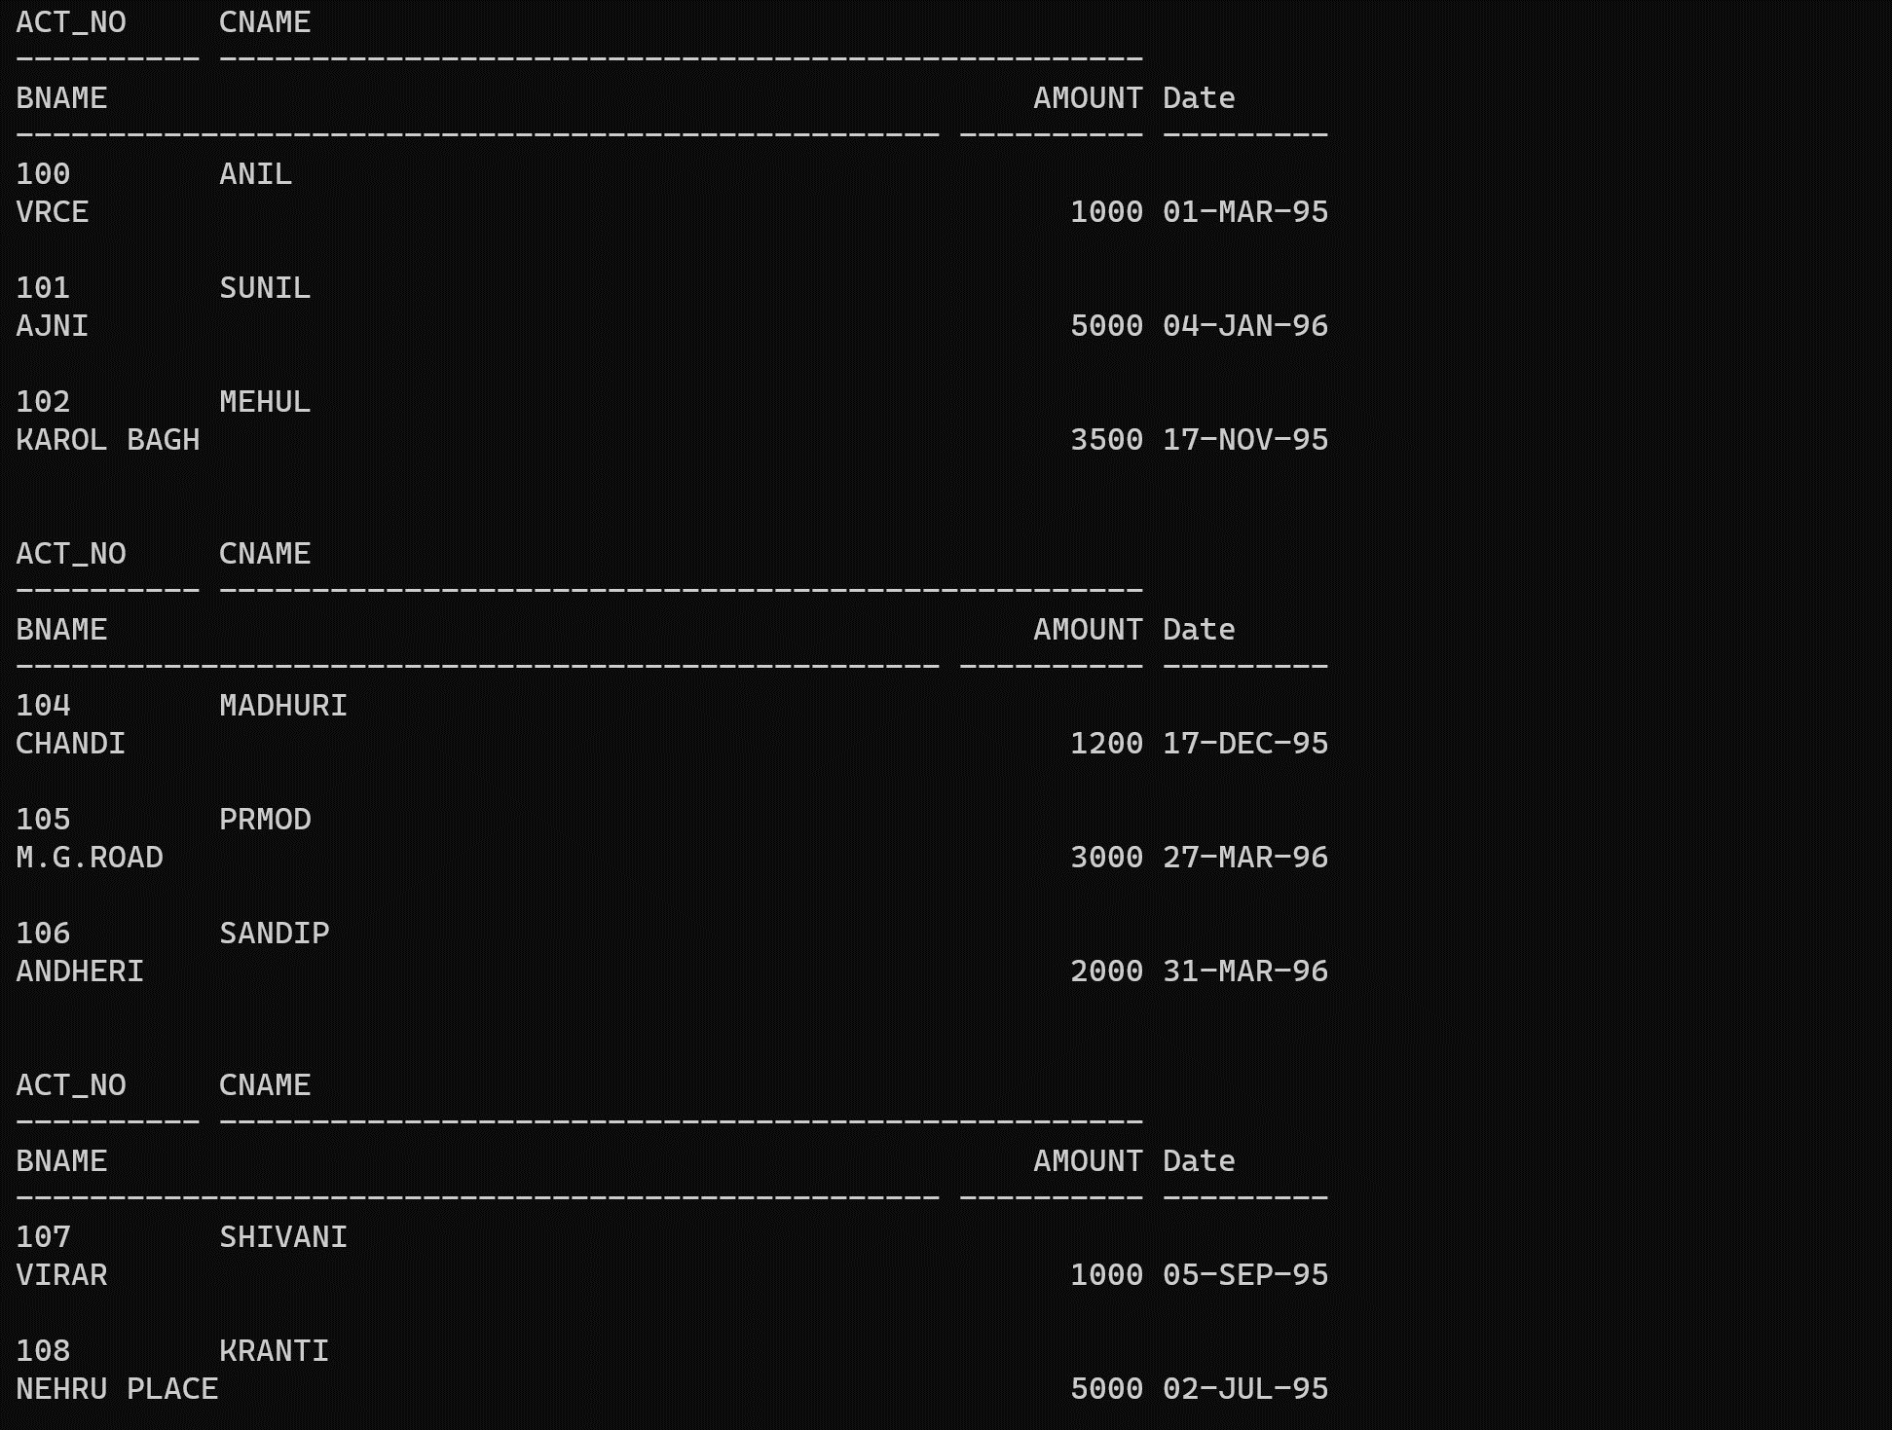

**TABLE-14: BORROW**

|  |  |  |  |
| --- | --- | --- | --- |
| **Loanno** | **Cname** | **Bname** | **Amount** |
| 201 | ANIL | VRCE | 1000.00 |
| 206 | MEHUL | AJNI | 5000.00 |
| 311 | SUNIL | DHARAMPETH | 3000.00 |
| 321 | MADHURI | ANDHERI | 2000.00 |
| 375 | PRMOD | VIRAR | 8000.00 |
| 481 | KRANTI | NEHRU PLACE | 3000.00 |

**INPUT:**

create table Borrow

(Loanno number(20), Cname varchar2(20), Bname varchar2(20), Amount number(20.00));

insert into Borrow (Loanno,Cname,Bname,Amount) values ('201','ANIL','VRCE','1000.00');

insert into Borrow (Loanno,Cname,Bname,Amount) values ('206','MEHUL','AJNI','5000.00');

insert into Borrow (Loanno,Cname,Bname,Amount) values ('311','SUNIL','DHARAMPETH','3000.00');

insert into Borrow (Loanno,Cname,Bname,Amount) values ('321','MADHURI','ANDHERI','2000.00');

insert into Borrow (Loanno,Cname,Bname,Amount) values ('375','PRMOD','VIRAR','8000.00');

insert into Borrow (Loanno,Cname,Bname,Amount) values ('481','KRANTI','NEHRU PLACE','3000.00');

**OUTPUT:** 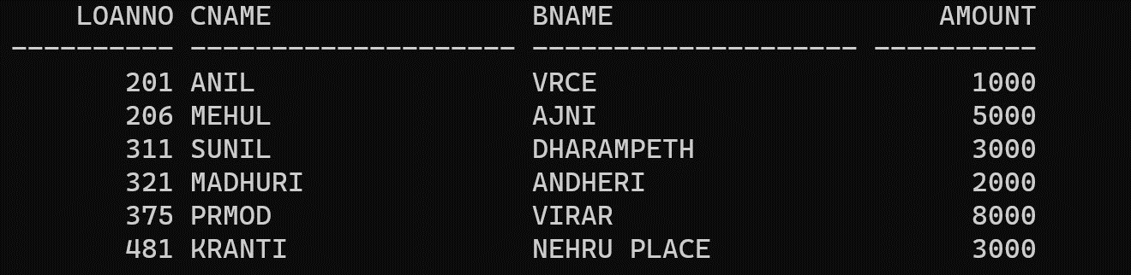

**TABLE-15: BRANCH**

|  |  |
| --- | --- |
| **Bname** | **City** |
| VRCE | NAGPUR |
| AJNI | NAGPUR |
| KAROLBAGH | DELHI |
| CHANDI | DELHI |
| DHARAMPETH | NAGPUR |
| M.G.ROAD | BANGLORE |
| ANDHERI | BOMBAY |
| VIRAR | BOMBAY |
| NEHRU PLACE | DELHI |
| POWAI | BOMBAY |

**INPUT:**

create table Branch

(Bname varchar2(20), City varchar2(20));

insert into Branch (Bname,City) values ('VRCE','NAGPUR');

insert into Branch (Bname,City) values ('AJNI','NAGPUR');

insert into Branch (Bname,City) values ('KAROLBAGH','DELHI');

insert into Branch (Bname,City) values ('CHANDI','DELHI');

insert into Branch (Bname,City) values ('DHARAMPETH','NAGPUR');

insert into Branch (Bname,City) values ('M.G.ROAD','BANGALORE');

insert into Branch (Bname,City) values ('ANDHERI','BOMBAY');

insert into Branch (Bname,City) values ('VIRAR','BOMBAY');

insert into Branch (Bname,City) values ('NEHRU PLACE','DELHI');

insert into Branch (Bname,City) values ('POWAI','BOMBAY');

select * from Branch

**OUTPUT**

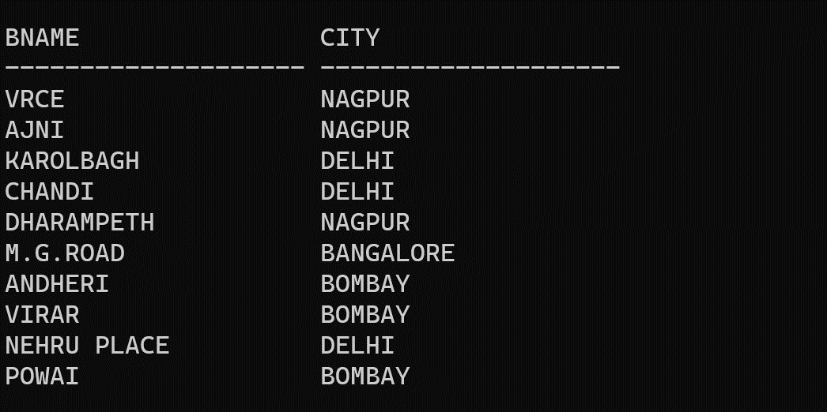

**TABLE-16: CUSTOMERS**

|  |  |
| --- | --- |
| **Cname** | **City** |
| ANIL | CALCUTTA |
| SUNIL | DELHI |
| MEHUL | BARODA |
| MANDAR | PATNA |
| MADHURI | NAGPUR |
| PRAMOD | NAGPUR |
| SANDIP | SURAT |
| SHIVANI | BOMBAY |
| KRANTI | BOMBAY |
| NAREN | BOMBAY |

**INPUT:**

create table Customers

(Cname varchar2(20), City varchar2(20));

insert into Customers (Cname,City) values ('ANIL','CALCUTTA');

insert into Customers (Cname,City) values ('SUNIL','DELHI');

insert into Customers (Cname,City) values ('MEHUL','BARODA');

insert into Customers (Cname,City) values ('MANDAR','PATNA');

insert into Customers (Cname,City) values ('MADHURI','NAGPUR');

insert into Customers (Cname,City) values ('PRAMOD','NAGPUR');

insert into Customers (Cname,City) values ('SANDIP','SURAT');

insert into Customers (Cname,City) values ('SHIVANI','BOMBAY');

insert into Customers (Cname,City) values ('KRANTI','BOMBAY');

insert into Customers (Cname,City) values ('NAREN','BOMBAY');

select * from Customers

**OUTPUT:**

